SIMATS ENGINEERING
ASSESSMENT TOOL
COURSE NAME: Theory of Computation COURSE CODE: CSA1304
COURSE OUTCOME COVERED
CO1: Analyze fundamental mathematical concepts of automata theory for formal languages and decision problems.(BL:3)
Assessment Tool Weightage: 40%
QUESTIONS: 5 Total Marks:25 Duration : 1 Hour
Analytical Problem
Code of Conduct:
I M.SRIVARSHA-192371010 (Name / Reg No) certify that this submission is my original work and that I have adhered to the guidelines specified for this assessment.
I understand that any violation of academic integrity rules will result in disciplinary action.

Signature of the student: M.SRIVARSHA

SIMATS ENGINEERING
ASSESSMENT TOOL
1.Consider the NFA given below which accepts some language L over the alphabet ��={a,b}. Construct a DFA that represents the same language L
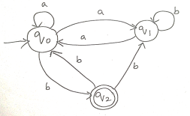

Given NFA:
- States: Q={q0,q1,q2}Q=\{q_0,q_1,q_2\}Q={q0​,q1​,q2​}
- Alphabet: Σ={a,b}\Sigma=\{a,b\}Σ={a,b}
- Initial state: q0q_0q0​
- Final state: q2q_2q2​
From the given diagram, the NFA transitions are:
δ(q0,a)={q0,q1}\delta(q_0,a)=\{q_0,q_1\}δ(q0​,a)={q0​,q1​} δ(q0,b)={q2}\delta(q_0,b)=\{q_2\}δ(q0​,b)={q2​} δ(q1,a)={q0}\delta(q_1,a)=\{q_0\}δ(q1​,a)={q0​} δ(q1,b)={q1}\delta(q_1,b)=\{q_1\}δ(q1​,b)={q1​} δ(q2,a)=∅\delta(q_2,a)=\varnothingδ(q2​,a)=∅ δ(q2,b)={q0,q1}\delta(q_2,b)=\{q_0,q_1\}δ(q2​,b)={q0​,q1​}

Step 1: Subset Construction
The DFA states are sets of NFA states.
Start with:
A={q0}A=\{q_0\}A={q0​}

From A={q0}A=\{q_0\}A={q0​}
- On aaa:
δ(A,a)={q0,q1}=B\delta(A,a)=\{q_0,q_1\}=Bδ(A,a)={q0​,q1​}=B
- On bbb:
δ(A,b)={q2}=C\delta(A,b)=\{q_2\}=Cδ(A,b)={q2​}=C

From B={q0,q1}B=\{q_0,q_1\}B={q0​,q1​}
- On aaa:
δ(B,a)=δ(q0,a)∪δ(q1,a)\delta(B,a)=\delta(q_0,a)\cup\delta(q_1,a)δ(B,a)=δ(q0​,a)∪δ(q1​,a) ={q0,q1}∪{q0}={q0,q1}=B=\{q_0,q_1\}\cup\{q_0\} =\{q_0,q_1\}=B={q0​,q1​}∪{q0​}={q0​,q1​}=B
- On bbb:
δ(B,b)=δ(q0,b)∪δ(q1,b)\delta(B,b)=\delta(q_0,b)\cup\delta(q_1,b)δ(B,b)=δ(q0​,b)∪δ(q1​,b) ={q2}∪{q1}={q1,q2}=D=\{q_2\}\cup\{q_1\} =\{q_1,q_2\}=D={q2​}∪{q1​}={q1​,q2​}=D

From C={q2}C=\{q_2\}C={q2​}
- On aaa:
δ(C,a)=∅=E\delta(C,a)=\varnothing=Eδ(C,a)=∅=E
- On bbb:
δ(C,b)={q0,q1}=B\delta(C,b)=\{q_0,q_1\}=Bδ(C,b)={q0​,q1​}=B

From D={q1,q2}D=\{q_1,q_2\}D={q1​,q2​}
- On aaa:
δ(D,a)={q0}∪∅={q0}=A\delta(D,a)=\{q_0\}\cup\varnothing =\{q_0\}=Aδ(D,a)={q0​}∪∅={q0​}=A
- On bbb:
δ(D,b)={q1}∪{q0,q1}={q0,q1}=B\delta(D,b)=\{q_1\}\cup\{q_0,q_1\} =\{q_0,q_1\}=Bδ(D,b)={q1​}∪{q0​,q1​}={q0​,q1​}=B

From E=∅E=\varnothingE=∅
The dead state loops to itself:
δ(E,a)=E,δ(E,b)=E\delta(E,a)=E,\qquad \delta(E,b)=Eδ(E,a)=E,δ(E,b)=E

DFA Transition Table
DFA State | NFA State Set | aaa | bbb
AAA | {q0}\{q_0\}{q0​} | BBB | CCC
BBB | {q0,q1}\{q_0,q_1\}{q0​,q1​} | BBB | DDD
CCC | {q2}\{q_2\}{q2​} | EEE | BBB
DDD | {q1,q2}\{q_1,q_2\}{q1​,q2​} | AAA | BBB
EEE | ∅\varnothing∅ | EEE | EEE

Final State
A DFA state is final if it contains the NFA final state q2q_2q2​.
Therefore:
FDFA={C,D}F_{DFA}=\{C,D\}FDFA​={C,D}
because:
C={q2},D={q1,q2}C=\{q_2\},\qquad D=\{q_1,q_2\}C={q2​},D={q1​,q2​}

Equivalent DFA
MD=(QD,Σ,δD,A,{C,D})M_D=(Q_D,\Sigma,\delta_D,A,\{C,D\})MD​=(QD​,Σ,δD​,A,{C,D})
where:
QD={A,B,C,D,E}Q_D=\{A,B,C,D,E\}QD​={A,B,C,D,E}
and the transitions are given in the table above.

State Diagram Description
- A→aBA \xrightarrow{a} BAa​B
- A→bCA \xrightarrow{b} CAb​C
- B→aBB \xrightarrow{a} BBa​B
- B→bDB \xrightarrow{b} DBb​D
- C→aEC \xrightarrow{a} ECa​E
- C→bBC \xrightarrow{b} BCb​B
- D→aAD \xrightarrow{a} ADa​A
- D→bBD \xrightarrow{b} BDb​B
- E→a,bEE \xrightarrow{a,b} EEa,b​E
Start state: AAA
Final states: C,DC,DC,D
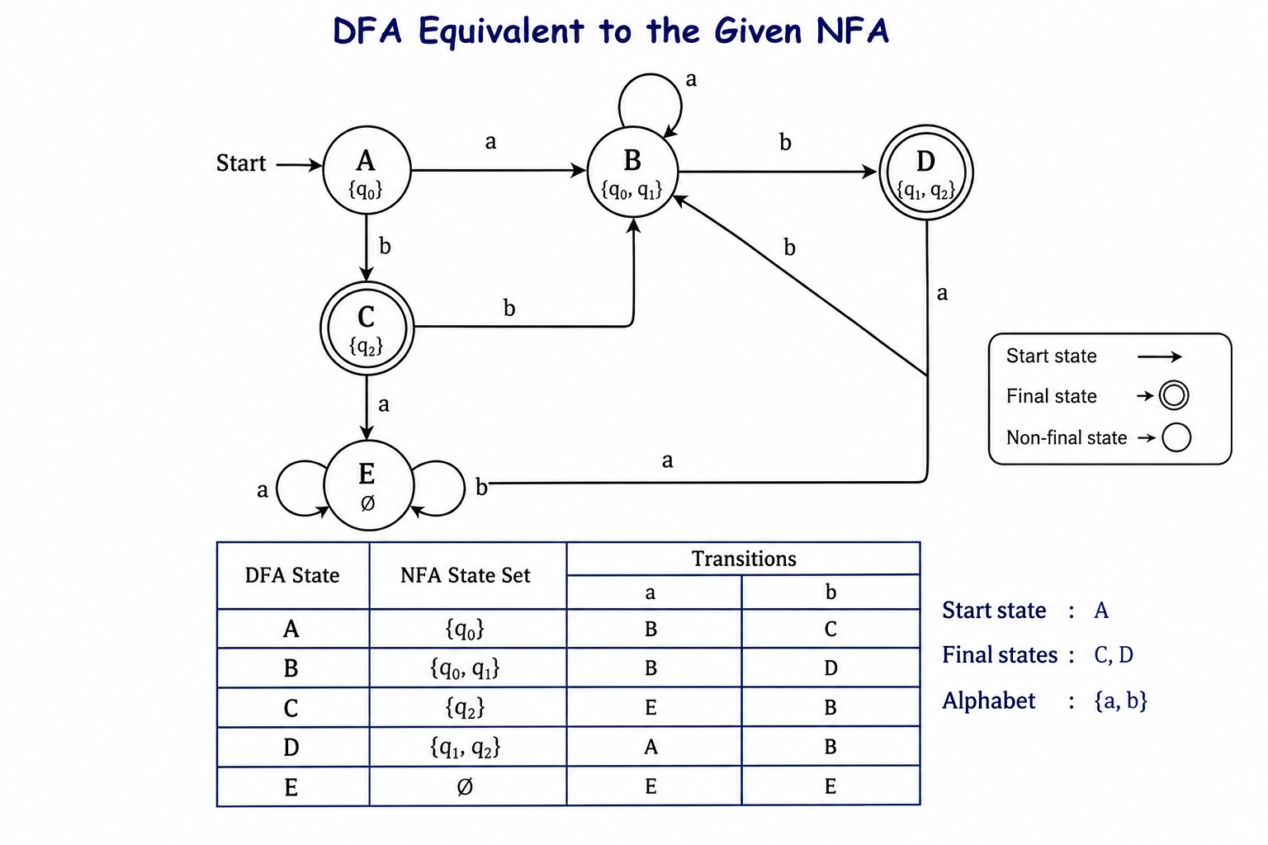

2.Let L be the language of words of length atleast 2 whose last two letters are difference from each other. For example abaab is in L but not bb, Construct an NFA for L, Then draw the equivalent DFA

Assume the alphabet is:
Σ={a,b}\Sigma=\{a,b\}Σ={a,b}
The language is:
L={w∈{a,b}∗∣∣w∣≥2 and the last two symbols are different}L=\{w\in\{a,b\}^* \mid |w|\geq2 \text{ and the last two symbols are different}\}L={w∈{a,b}∗∣∣w∣≥2 and the last two symbols are different}
Therefore, a string is accepted if it ends in:
aborbaab \quad \text{or} \quad baaborba
For example:
- abaababaababaab → ends in ab → accepted
- bbbbbb → ends in bb → rejected
- abaabaaba → ends in ba → accepted

1. NFA Construction

NFA States
Q={q0,q1,q2,qf}Q=\{q_0,q_1,q_2,q_f\}Q={q0​,q1​,q2​,qf​}
- q0q_0q0​: Start state
- qfq_fqf​: Final state

NFA Transitions
The NFA reads any number of symbols first and non-deterministically guesses the beginning of the last two symbols.
δ(q0,a)={q0,q1}\delta(q_0,a)=\{q_0,q_1\}δ(q0​,a)={q0​,q1​} δ(q0,b)={q0,q2}\delta(q_0,b)=\{q_0,q_2\}δ(q0​,b)={q0​,q2​} δ(q1,b)={qf}\delta(q_1,b)=\{q_f\}δ(q1​,b)={qf​} δ(q2,a)={qf}\delta(q_2,a)=\{q_f\}δ(q2​,a)={qf​}

Equivalent DFA by Subset Construction
Let:
A={q0}A=\{q_0\}A={q0​}
This is the start state.

DFA States
A={q0}A=\{q_0\}A={q0​} B={q0,q1}B=\{q_0,q_1\}B={q0​,q1​} C={q0,q2}C=\{q_0,q_2\}C={q0​,q2​} D={q0,q1,qf}D=\{q_0,q_1,q_f\}D={q0​,q1​,qf​} E={q0,q2,qf}E=\{q_0,q_2,q_f\}E={q0​,q2​,qf​}
The DFA final states are the subsets containing qfq_fqf​:
F={D,E}F=\{D,E\}F={D,E}

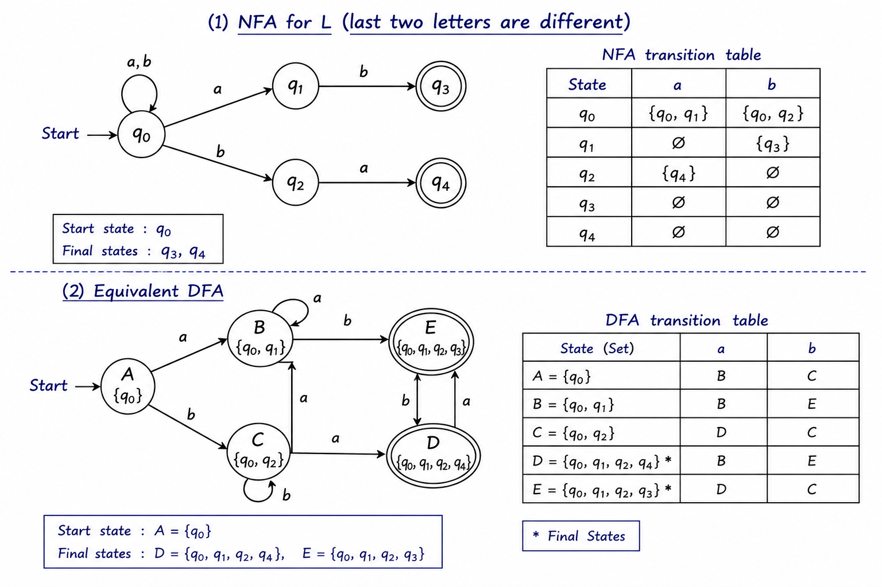

3. Design a Nondeterministic Finite Automata (NFA) that takes a binary string as input and accepts the string only if the last two digits are the same (either 00 or 11). Write the formal definition of the NFA. Also show that the string 01011 is accepted by the NFA
We need to design an NFA over the binary alphabet:
Σ={0,1}\Sigma=\{0,1\}Σ={0,1}
that accepts a string only when its last two digits are the same.
Therefore, the accepted strings must end with either:
00or1100 \quad \text{or} \quad 1100or11
Thus,
L={w∈{0,1}∗∣w ends with 00 or 11}L=\{w\in\{0,1\}^* \mid w \text{ ends with }00\text{ or }11\}L={w∈{0,1}∗∣w ends with 00 or 11}

1. Formal Definition of the NFA
The NFA is defined as:
M=(Q,Σ,δ,q0,F)M=(Q,\Sigma,\delta,q_0,F)M=(Q,Σ,δ,q0​,F)
where:
Q={q0,q1,q2,q3,qf}Q=\{q_0,q_1,q_2,q_3,q_f\}Q={q0​,q1​,q2​,q3​,qf​} Σ={0,1}\Sigma=\{0,1\}Σ={0,1} q0=initial stateq_0=\text{initial state}q0​=initial state F={qf}F=\{q_f\}F={qf​}

Transition Function
δ(q0,0)={q0,q1}\delta(q_0,0)=\{q_0,q_1\}δ(q0​,0)={q0​,q1​} δ(q0,1)={q0,q2}\delta(q_0,1)=\{q_0,q_2\}δ(q0​,1)={q0​,q2​} δ(q1,0)={qf}\delta(q_1,0)=\{q_f\}δ(q1​,0)={qf​} δ(q2,1)={qf}\delta(q_2,1)=\{q_f\}δ(q2​,1)={qf​}
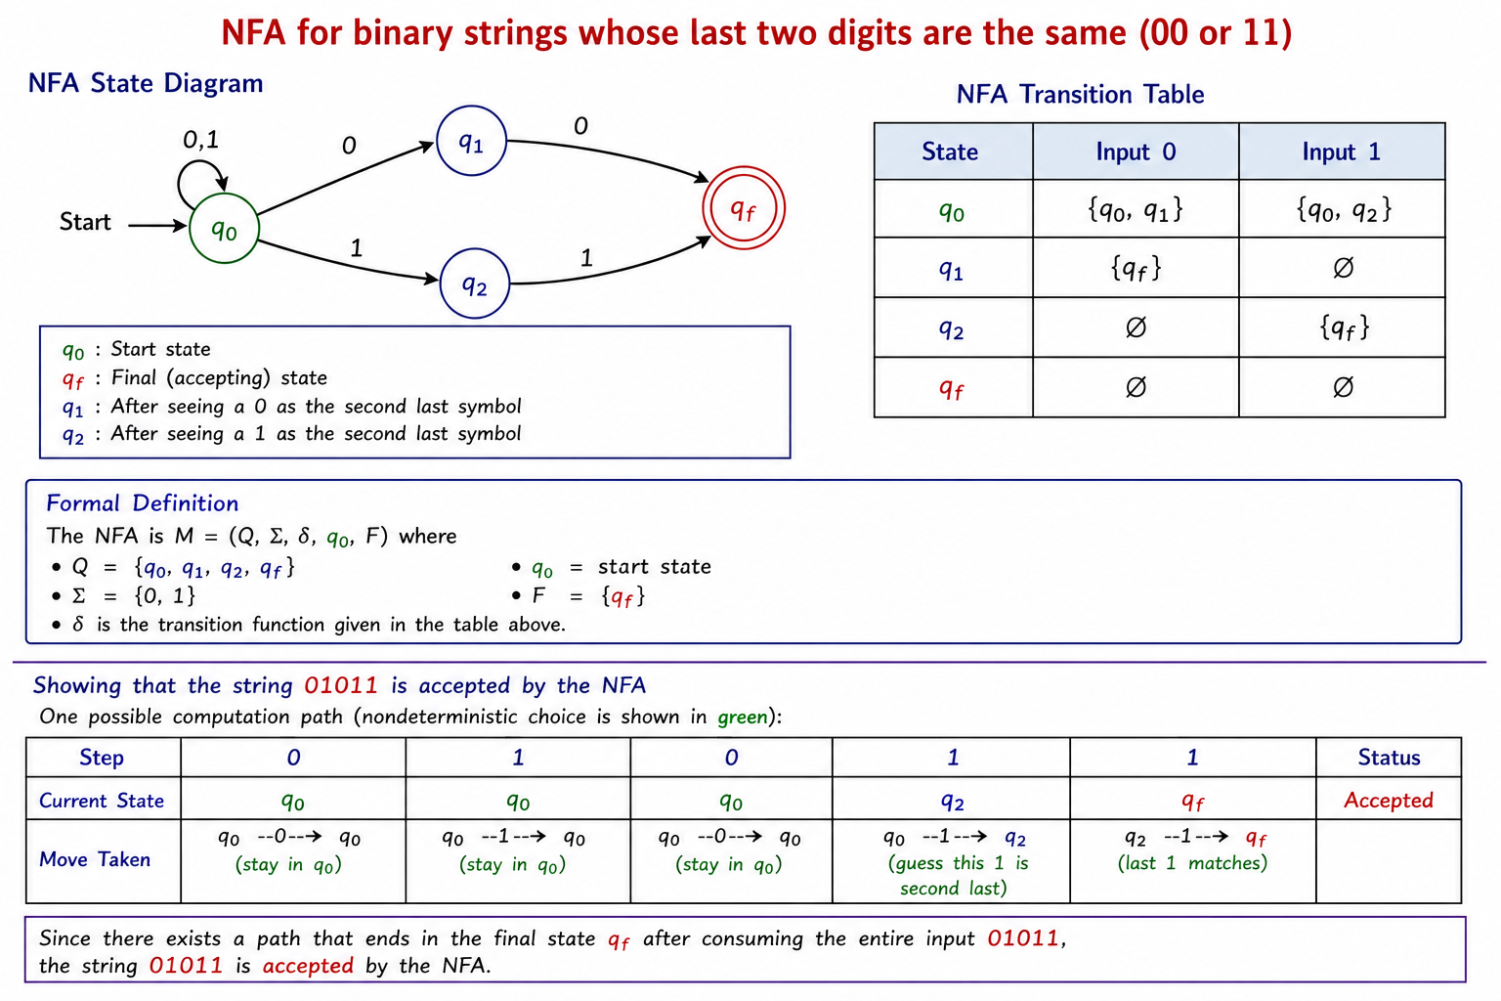
4. Consider the NFA given below which accepts the language representing the set of all strings having 001 as a substring over the alphabet ��={0,1}. Construct a DFA that represents the same language.
The language is:
L={w∈{0,1}∗∣the substring 001 occurs in w}L=\{w\in\{0,1\}^* \mid \text{the substring }001\text{ occurs in }w\}L={w∈{0,1}∗∣the substring 001 occurs in w}
That means the DFA must remember how much of the pattern 001 has been matched.

DFA States
- AAA: No part of 001 matched
- BBB: Last symbol is 0
- CCC: Last two symbols are 00
- DDD: 001 has been found — final state
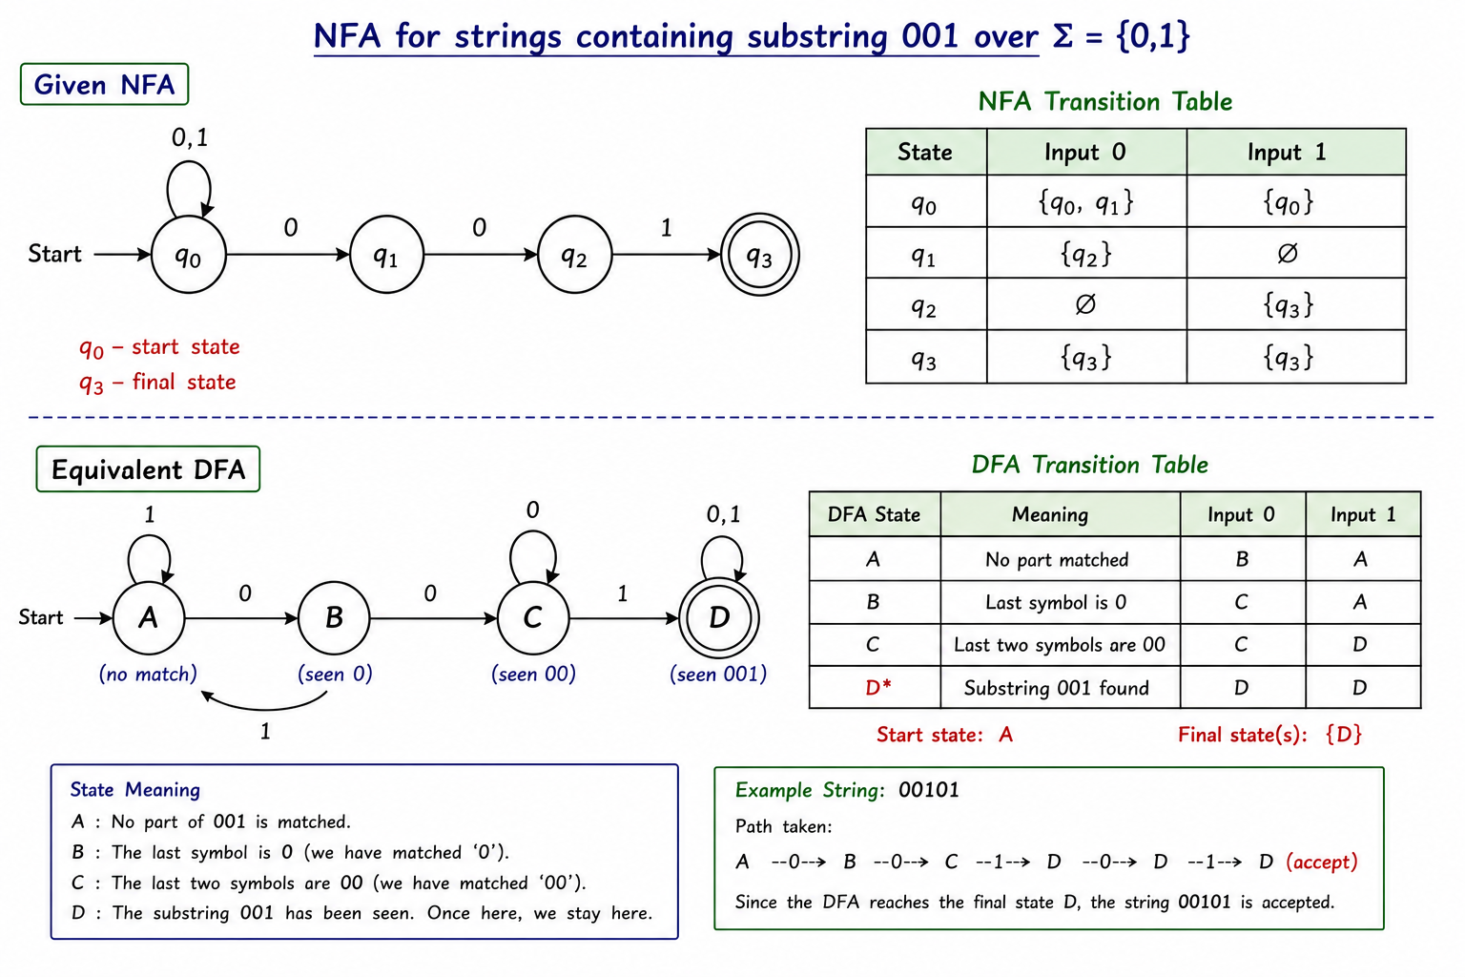
- Start state: AAA
- Final state: DDD
- Therefore, this DFA accepts exactly those binary strings that contain 001 as a substring, such as 001, 0001, 10010, and 010011.

5. A NFA with ε-transitions is given below. Find ε-closure for each state and Design an equivalent DFA which accepts the same language. Draw its transition table and mark the initial and final states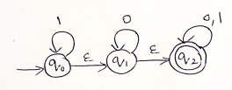

Given NFA
The NFA has:
- States: Q={q0,q1,q2}Q=\{q_0,q_1,q_2\}Q={q0​,q1​,q2​}
- Alphabet: Σ={0,1}\Sigma=\{0,1\}Σ={0,1}
- Initial state: q0q_0q0​
- Final state: q2q_2q2​
Transitions:
- q0→1q0q_0 \xrightarrow{1} q_0q0​1​q0​
- q0→εq1q_0 \xrightarrow{\varepsilon} q_1q0​ε​q1​
- q1→0q1q_1 \xrightarrow{0} q_1q1​0​q1​
- q1→εq2q_1 \xrightarrow{\varepsilon} q_2q1​ε​q2​
- q2→0,1q2q_2 \xrightarrow{0,1} q_2q2​0,1​q2​

1. ε-Closure of Each State
The ε\varepsilonε-closure of a state is the set of states reachable from that state using zero or more ε\varepsilonε-transitions.

For q0q_0q0​
From q0q_0q0​:
q0→εq1q_0 \xrightarrow{\varepsilon} q_1q0​ε​q1​
and
q1→εq2q_1 \xrightarrow{\varepsilon} q_2q1​ε​q2​
Therefore:
ε-closure(q0)={q0,q1,q2}\boxed{\varepsilon\text{-closure}(q_0)=\{q_0,q_1,q_2\}}ε-closure(q0​)={q0​,q1​,q2​}​

For q1q_1q1​
From q1q_1q1​:
q1→εq2q_1 \xrightarrow{\varepsilon} q_2q1​ε​q2​
Therefore:
ε-closure(q1)={q1,q2}\boxed{\varepsilon\text{-closure}(q_1)=\{q_1,q_2\}}ε-closure(q1​)={q1​,q2​}​

For q2q_2q2​
There are no outgoing ε\varepsilonε-transitions from q2q_2q2​.

2. DFA Construction Using Subset Construction
Let the DFA states be:
A={q0,q1,q2}A=\{q_0,q_1,q_2\}A={q0​,q1​,q2​} B={q1,q2}B=\{q_1,q_2\}B={q1​,q2​} C={q2}C=\{q_2\}C={q2​}
The initial DFA state is:
A=ε-closure(q0)={q0,q1,q2}\boxed{A=\varepsilon\text{-closure}(q_0)=\{q_0,q_1,q_2\}}A=ε-closure(q0​)={q0​,q1​,q2​}​
A DFA state is final if it contains the NFA final state q2q_2q2​.
Therefore, all three DFA states contain q2q_2q2​, so:
FDFA={A,B,C}\boxed{F_{DFA}=\{A,B,C\}}FDFA​={A,B,C}​

3. DFA Transition Table
DFA State | Corresponding NFA States | Input 000 | Input 111
AAA | {q0,q1,q2}\{q_0,q_1,q_2\}{q0​,q1​,q2​} | BBB | AAA
BBB | {q1,q2}\{q_1,q_2\}{q1​,q2​} | BBB | CCC
CCC | {q2}\{q_2\}{q2​} | CCC | CCC

Initial State
A={q0,q1,q2}\boxed{A=\{q_0,q_1,q_2\}}A={q0​,q1​,q2​}​

Final States
A,B,C\boxed{A,B,C}A,B,C​
since each state contains q2q_2q2​.

4. Equivalent DFA
The equivalent DFA is:
MD=(QD,Σ,δD,A,FD)M_D=(Q_D,\Sigma,\delta_D,A,F_D)MD​=(QD​,Σ,δD​,A,FD​)
where:
QD={A,B,C}Q_D=\{A,B,C\}QD​={A,B,C} Σ={0,1}\Sigma=\{0,1\}Σ={0,1} FD={A,B,C}F_D=\{A,B,C\}FD​={A,B,C}
Thus, the DFA accepts the same language as the given NFA.
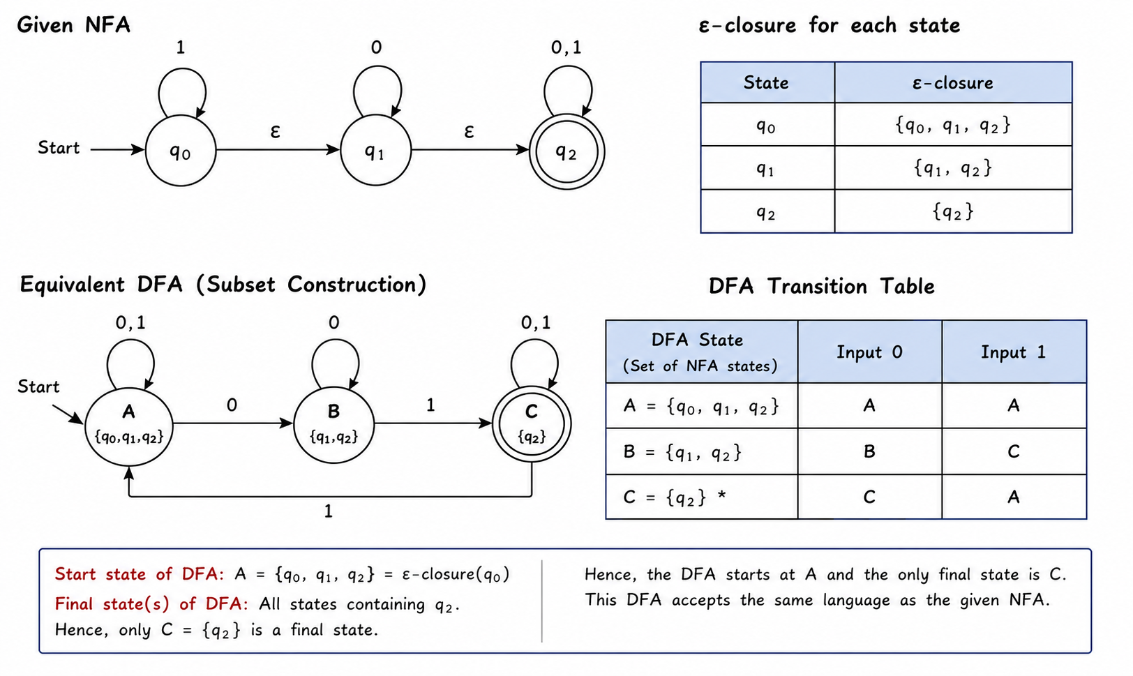

SIMATS ENGINEERING
ASSESSMENT TOOL
RUBRICS FOR CALCULATION
Criteria | Weightage | Level 4 –  Exemplary (5 Marks) | Level 3 –  Proficient (4 Marks) | Level 2 –  Developing (2–3 Marks) | Level 1 –  Beginning (0–1 Mark)
Conceptual Understandin g | 30 | Demonstrates clear and  complete  understanding of the concept | Good  understanding with minor  gaps | Basic  understanding with some  misconceptions | Poor or  incorrect  understandin g
Accuracy of Answer | 25 | Completely  correct answer with no errors | Mostly correct with minor  errors | Partially correct with noticeable errors | Incorrect or irrelevant  answer
Application of Knowledge | 20 | Correctly applies concepts to solve the  question/problem | Applies  concepts with minor mistakes | Limited or  partially correct application | No or  incorrect  application
Completeness of Response | 15 | Covers all  required parts of the question | Covers most parts with  minor  omissions | Covers only  some parts | Incomplete or missing  response
Clarity &  Presentation | 10 | Clear, concise, and well  organized answer | Understandabl e with minor issues | Somewhat  unclear or poorly structured | Difficult to  understand

